Name ____________________________

CLASSIFICATION STUDY GUIDE

- What do you call the 2-word naming system used by scientists?

- What is the scientific name for humans?

- Canis familiaris is the scientific name for a dog. Which genus do dogs belong to? _________________ Which species do dogs belong to? __________________

- Name the 6 kingdoms of life.

- Starting with the broadest, list the classification scheme used for living things.

- Complete the table below about the characteristics of the 6 different kingdoms.

 | Archae-bacteria | Eubacteria | Protists | Fungi | Plants | Animals
Prokaryotic or Eukaryotic
Unicellular or Multicellular
Move?
Autotroph or Heterotroph
Example

- Define the following:

Prokaryotic:

Eukaryotic:

Unicellular:

Multicellular:

Autotroph:

Heterotroph:

- What are some reasons scientists use scientific names for organisms?

- Look at the pictures of the bird beaks below. Identify the genus of each bird by using the dichotomous key.

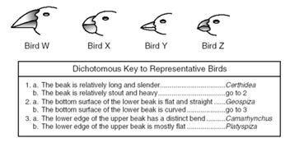

Bird W ___________________________
Bird X ___________________________
Bird Y ___________________________
Bird Z ___________________________

