Transversals and Parallel Lines
Name: _________________________ Doctor or Dentist: _________________
Word | Meaning
Parallel
Transversal
Exterior
Interior
Alternate
Consecutive

Alternate Exterior Alternate Interior
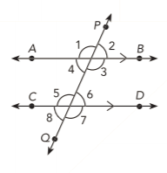

Consecutive Exterior Consecutive Interior

Vertical Angles Corresponding Angles

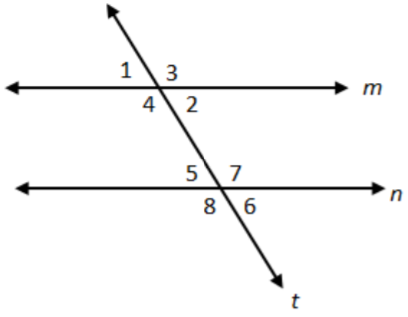
Line $m$ is parallel to line $n$. Tell if the angles are corresponding, alternate interior, alternate exterior, consecutive interior, consecutive exterior, or none of these.

$∠1$ and $∠5$ _____________________
$∠2$ and $∠7$ _____________________
$∠3$ and $∠5$ _____________________
$∠3$ and $∠8$ _____________________
$∠4$ and $∠7$ _____________________
$∠4$ and $∠8$ _____________________

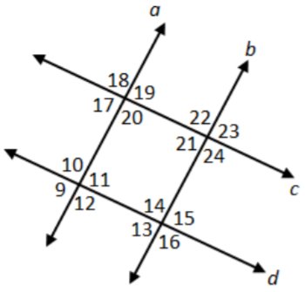
Line $a$ is parallel to line $b$. Line $c$ is parallel to line $d$. Name the transversal for each pair. Then tell if the angles are corresponding, alternate interior, alternate exterior, consecutive interior, consecutive exterior, or none of these.

$∠12$ and $∠18$ _____________________
$∠20$ and $∠21$ _____________________
$∠10$ and $∠16$ _____________________
$∠13$ and $∠21$ _____________________
$∠20$ and $∠22$ _____________________
$∠11$ and $∠17$ _____________________
$∠15$ and $∠24$ _____________________
Transversal and Parallel Lines Discovery:
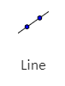
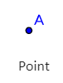
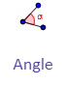
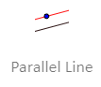
https://www.geogebra.org/geometry
Tools needed:
- Using the line tool, construct a line.
- Using the parallel line tool, click on one point from the first line and a random spot. Use the point tool to create another point on the line.
- Using the line tool, construct a transversal by clicking on both parallel lines. Use the point tool to create two other points outside the parallel lines.
- Using the angle tool, quick on three points to find the measure of that angle. Do this to all angles and fill in the table below.
Angle
Measure

Which angles are congruent?

Alternate Exterior | Alternate Interior | Consecutive Exterior | Consecutive Interior | Corresponding

