I DO: Read "The Flaming Sky" on pages 4-11 in Scholastic Scope October 2016 issue and the teacher will model asking the 1 question and providing the 1st corresponding answers using supporting text evidence in the beginning of the text.
Section 1:
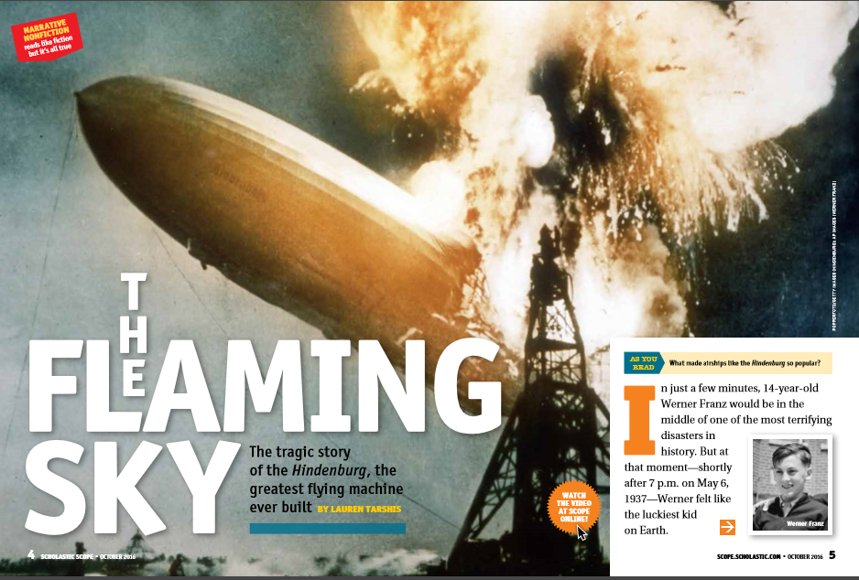

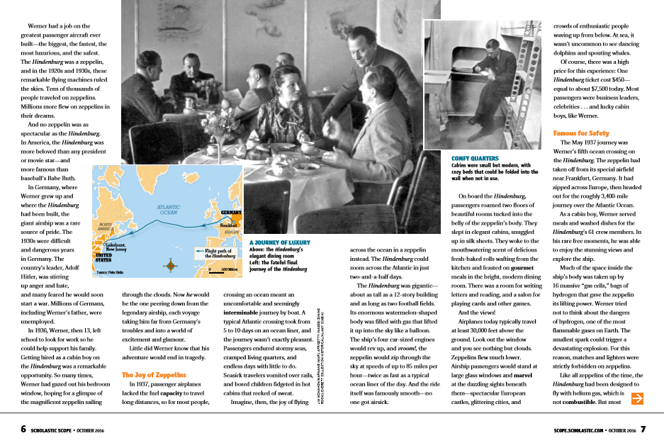

(Section 1) Q1: | (Section 1) A1.
Section 2 WE DO: Continue reading "The Flaming Sky" on pages 4-11 in Scholastic Scope October 2016 issue and the teacher with student input will ask a 2nd question and provide a 2nd corresponding answer using supporting text evidence for the middle of the text.
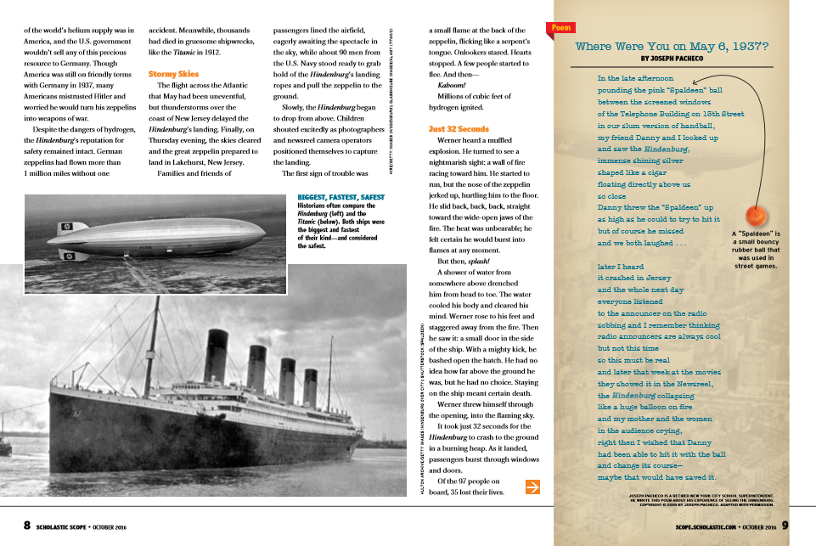

Teacher creates a question: | Students answer the question:
(Section 2) Q2 | (Section 2) A2
Section 3: You Do It Together With a partner continue reading "The Flaming Sky" on pages 4-11 in Scholastic Scope October 2016 issue and in pairs ask and formulate a 3rd question and provide a 3rd corresponding answer using supporting text evidence for the end of the text.
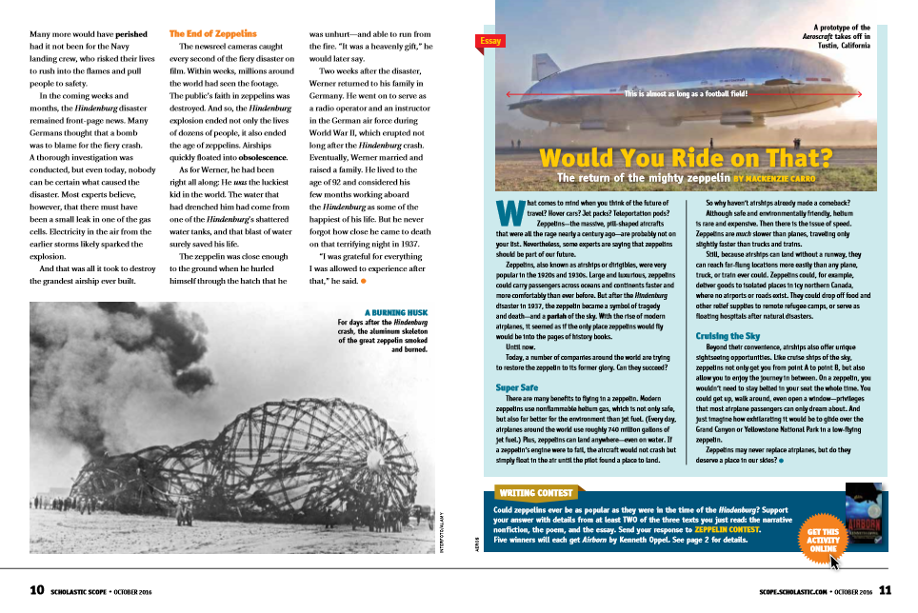

Partner #1: Creates the question | Partner #2: Answers the question
(Section 3) Q3 | (Section 3) A3
YOU DO: Research and read his or own text on a non-fiction topic or individual and create a Q/A text structure for it, asking 3 questions and 3 corresponding answers that include text evidence and spans across the BME of the text.
Section 1B: Interview/Question #1 | Section 1B: Answer #1
Section 2M: Interview/Question #2 | Section 2M: Answer #2
Section #3E: Interview/Question #3 | Section #3E: Answer #3

