How do I identify and analyze compare/contrast text structure?
Identify? | Analyze?
I DO: Read "Should You Go Trash-Free at Lunch?" on pages 10-11 in Scholastic Scope March 2019 issue and compare/contrast the pros and cons of a trash-free lunch using supporting text evidence.
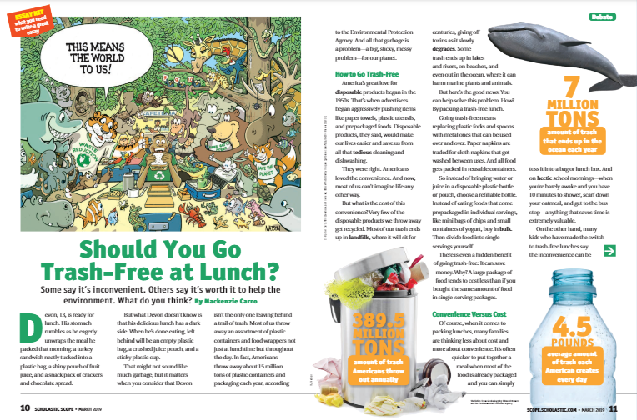
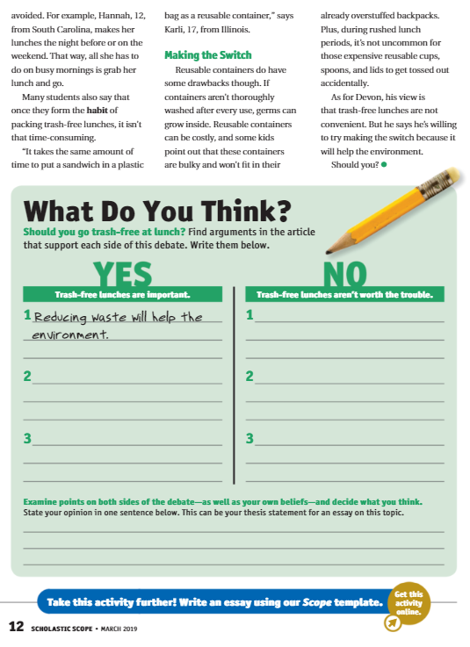
Section 2: Pros | Section 1: Cons
1. | 2.
2. | 2.
3. | 3.
Examine points on both sides of the debate and formulate an opinion, in a 15-word response.

How do I identify and analyze compare/contrast text structure? | Partner #1: Identify?
 | Partner #2: Analyze?
WE DO: Read “Should the School Week Be Shorter? Pages 28-29 Scholastic Scope February 2019 and compare/contrast how each author conveys that the school week should or should not be shorter using supporting text evidence in each one’s argument.
Section 1: YES  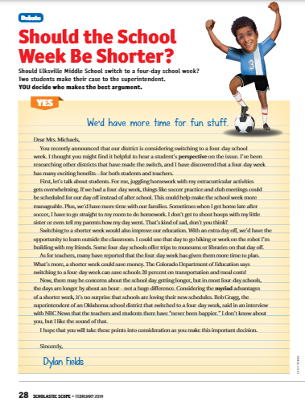 | Yes (3 Pros) We’d have more time for fun stuff.  1.
 | 2.
 | 3.
Section 2: NO  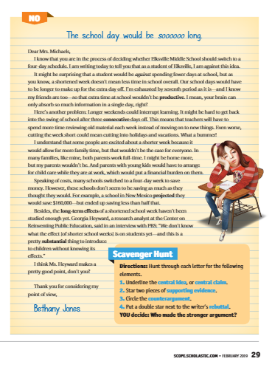 | NO: (3 Cons) The School Day would be soooooo long.  1.
 | 2.
 | 3.
Examine points on both sides of the debate and formulate an opinion, in a 15-word response.

Partner #1: Explain the purpose and how to make an effective comparison and contrast nonfiction piece. | Partner #2: Explain a real life example of two items that can be compared and contrasted (such as candidates for an election or between two countries to decide on a place to live.)
You Do It Together: Read “Which One Would You Eat?” Evaluate which one you would prefer to eat by providing 3 flavored reasons why you would select one over the other and 3 unflavored reasons why you wouldn’t eat the other.
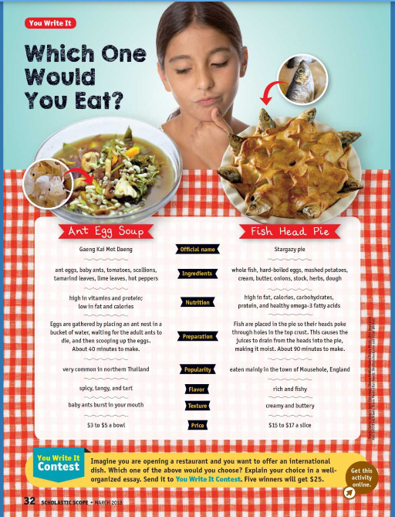 | Ant Egg Soup:
 | 1.
 | 2.
 | 3.
 | Fish Head Pie:
 | 1.
 | 2.
 | 3.
Examine points on both sides of the debate and formulate an infra-commercial why you defend eating one over the other. Sell it. Be sure to use 2 elements of comparisons/contrasts to present to your audience members as a selling point. Provide an illustration with your ad. In addition, have the audience vote @#anteggsoup.yum or @#fishheadpie.delish

Partner #1: Describe one main similarity the ant egg soup has in comparison of the fish head pie. | Partner #2: Describe one main difference the ant egg soup has in contrast from the fish head pie.
YOU DO: Read Find an article that you can compare and contrast the pros and cons of a topic and use evidence to support both sides of this argument.

Section 1: YES/Pros | No/Cons
1. | 1.
2. | 2.
3. | 3.
Examine points on both sides of the debate and formulate an opinion, in a 15-word response.

